**What is business Analytics? Explain the different types Of Analytics.**

* **Business Analytics (BA)** is the process of using data, statistical analysis, and technology to help businesses make better decisions.
* It involves collecting business data, analyzing it, and using the results to improve business performance and strategy.
* This uses various techniques and tools to process and transform data into valuable insights that can be used for decision-making.

**Types of Business Analytics:**

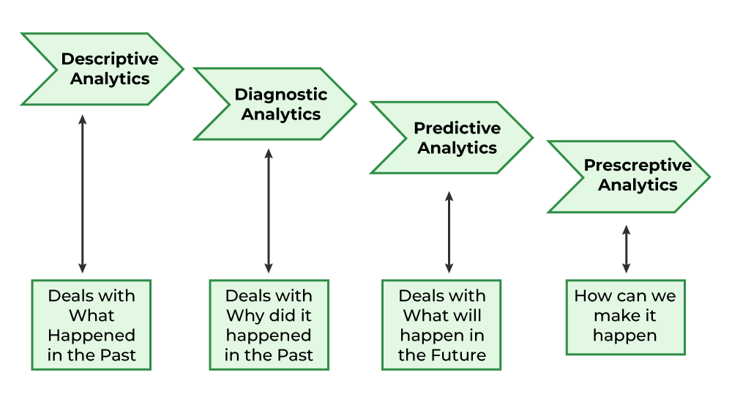

**Predictive Analytics**:

* Predictive analytics is a branch of data science that uses the statistical techniques, [machine learning](https://www.geeksforgeeks.org/machine-learning/), [data mining](https://www.geeksforgeeks.org/data-mining/), and [game theory](https://www.geeksforgeeks.org/game-theory/)to analyze current and historical facts to make predictions about a future outcomes.
* This powerful tool has become necessary in today's world, enabling organizations to predict trends, reduce risks, and make informed decisions.
* Predictive analytics helps identify and mitigate potential risks.
* Predictive models can optimize processes and resource allocation. Businesses can forecast demand and optimize inventory levels, or predict equipment maintenance needs

**How Predictive Analytics Modeling works?**

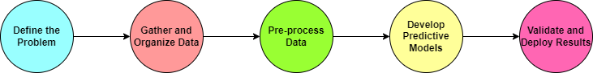

**Descriptive Analytics**

* **Descriptive Analytics** helps us understand what happened in the past by analyzing historical data.
* It helps identify patterns, trends, and relationships within the data, clearly showing **"what happened”**, **“what is currently happening"** and reasons behind past successes or failures.
* The main task of descriptive analytics is to create metrics and key performance indicators for use in dashboards and business reports.

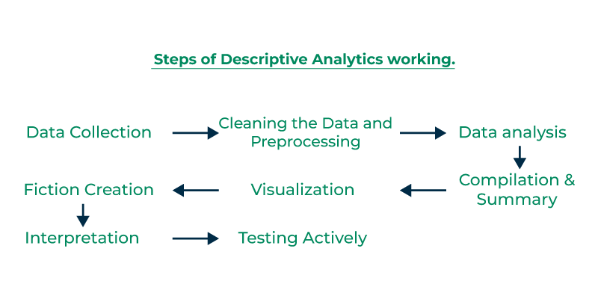**Prescriptive Analytics**

**Prescriptive Analytics** not only predicts what might happen but also **recommends actions** to take based on those predictions.

* It combines **big data**, **math models**, **business rules**, and **machine learning**.
* It tells **what to do next** to get the best results.
* It helps decision-makers understand the **impact of each choice**.
* It’s useful in areas like **healthcare planning**, where it analyzes both internal and external data to guide future strategies.

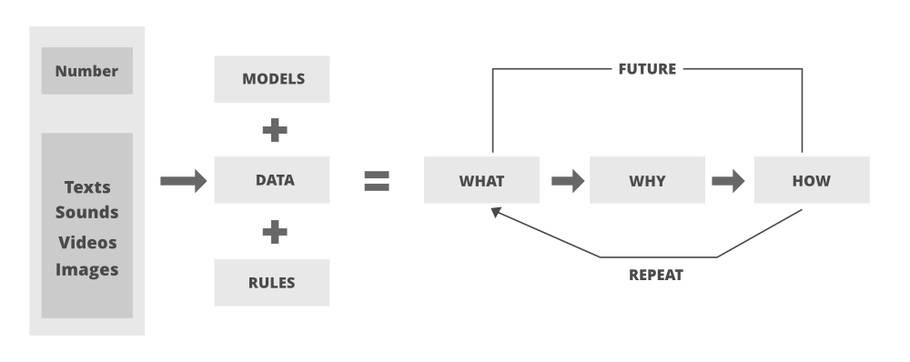

**Diagnostic Analytics**

**Diagnostic Analytics** plays an important role in today’s world of data in helping businesses to understand not just what happened but also why it happened.

It looks at **historical data** to find patterns, dependencies, or causes behind past outcomes.

* It digs deep into the data to understand the **root cause** of problems.
* Companies use it to gain detailed insights that help them **improve future performance**.
* It saves time by reusing existing data rather than starting fresh for each issue.

**Common techniques include:**

* **Data discovery** – exploring data to find useful patterns
* **Data mining** – extracting insights from large datasets
* **Correlation analysis** – finding relationships between variables

**Advantage:**

1. **Helps Make Better Decisions:** You can make smart choices based on data, not just guesses.
2. **Saves Time and Money:** It shows where things are slow or costly, so you can fix them.
3. **Can Predict the Future:** Helps you know what might happen next, like how much you’ll sell next month.
4. **Increases Profits:** By understanding customers and improving work, you can earn more money.
5. **Stay Ahead of Others:** If you use analytics, you can do better than your competitors.

**Disadvantages:**

1. **Can Be Expensive:** You need special tools and experts, which can cost a lot.
2. **Data Privacy Problems:** If data is not handled properly, customer information may leak.
3. **Hard to Understand:** Some tools are tricky, and not everyone can use them easily.
4. **Wrong Results if Data is Bad:** If the data is wrong or missing, the answer will also be wrong.
5. **Too Much Dependence on Data:** People might ignore their own thinking and only trust the numbers.